Myrtus Communis - Myrtle
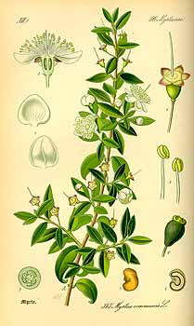
Myrtus (Myrtle) is a genus of one or two species of flowering plants in the family Myrtaceae, native to southern Europe and North Africa. It is the type genus of the family. The plant is an evergreen shrub or a small tree, with a fragrant essential oil. The common Myrtle, Myrtus Communis also called true Myrtle, is widespread in the Mediterranean region and is commonly cultivated.
Place of origin Part of plant used
Northern Israel Leaves
Method of Extraction Yield
Steam Distillation 0.7 %
Characteristic
Color: Clear Orange
Perfume notes: Sweet and pleasant
Therapeutic properties and uses
The essential oil of M. Communis is infrequently used in the foods and beverage industry. In the fragrance industry, it is usually found in combination with fragrances with a top note. In therapeutic aromatherapy, it is typically found in condition-specific or targeted formulations.
 |  |  | Chemical Composition
1,8-cineole 28.75 % | Oxides | α -Pinene 30.57 % |  | Monoterpenes
 |  | Limonene 5.35 %
Linolool 13.71 % | Monoterpenols | Para-Cymene 1.64 %
Geraniol 4.48 %
Myrtenol 4.11 % |  | ẟ-Elemene 2.53 % |  | Sesquiterpenes

Risk Phrases:
- Flammable
- Irritating to eyes, respiratory system and skin
- May cause sensitization by skin contact
- Very toxic to aquatic organisms, may cause long-term adverse effects in the aquatic environment

Safety Phrases:
- Avoid contact with skin and eyes
- Wear suitable gloves
- Avoid exposure
- Avoid release to the environment.
- If swallowed, do not induce vomiting: seek medical advice immediately

