Judean desert Artemisia - Artemisia Herba-Alba
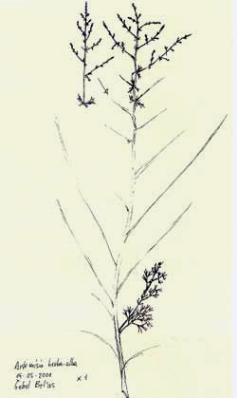
Artemisia Herba-Alba, also known as white wormwood, is a perennial shrub in the genus Artemisia that grows commonly on the steppes of the Mediterranean regions in Northern Africa, Western Asia and Southeast Europe. This species of sagebrush is widely used in herbal medicine for its antiseptic vermifuge and antispasmodic properties. Artemisia Herba Alba was reported as a traditional remedy of enteritis and various intestinal disturbances, among the Bedouins in the Negev desert. In fact essential oil showed antibacterial activity as well as antispasmodic activity on rabbits

Place of origin Part of plant used
Northern Israel Leaves, twigs and flowers
Method of Extraction
Steam Distillation
Characteristic
Perfume notes: Sweet herbaceous with a bitter tinge on the end-note

Therapeutic properties and uses
Artemisia Herba-alba water extract might lower blood sugar levels in some people with type 2 diabetes. Parasitic infections such as roundworms, pinworms, tapeworms, hookworms, and flukes. There is some evidence that taking an Artemisia Herba-alba water extract might reduce symptoms, lowered blood pressure and lowered heart rate and cure pinworm infections in adults and children. Can be used in cases of Stomach upset, common cold, measles, jaundice, anxiety, irregular heartbeat, muscle weakness and more.

Safety Phrases - (refers to the essential oil only):
- Avoid contact with skin and eyes
- Wear suitable gloves
- Avoid exposure
- Avoid release to the environment
- Do not use for children or during pregnancy

