Artemisia -Artemisia Arborescens
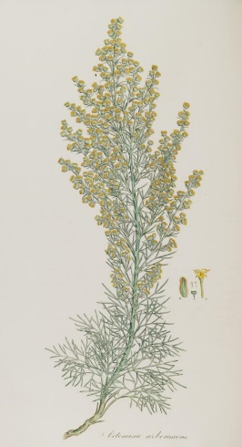
Artemisia Arborescens (tree wormwood) is a species of flowering plant in the family Asteraceae, native to the Mediterranean region. It is an erect evergreen perennial, with masses of finely divided aromatic silvery white leaves and single sided sprays of yellow daisy like flowers. This plant is cultivated for its foliage effects, but in colder temperate regions it requires the protection of a wall. This plant, like others of genus Artemisia, yields essential oils which historically been used for medicinal purposes, and its pharmacological properties are under investigation.
Place of origin Part of plant used
Northern Israel Leaves
Method of Extraction Yield
Steam Distillation 0.1-0.2 %
Characteristic
Color: Dark-blue
Perfume notes: Unique complex aroma
Therapeutic properties and uses
The Artemisia Essential oil is Anti-inflammatory, antihistaminic, calming effect on the parasympathetic Nervous System, Blood decongestant, Artemisia oil can be used for dermatosis, allergic reactions, itchiness, lymphatic drainage, venous congestions, Asthma, hay fever, asthmatic bronchitis
 |  |  | Chemical Composition
Camphor 27.26 % | Katones | γ-Terpinene 2.47 % |  | Monoterpenes
Trans-Thujone 24.97 % |  | α-Pinene 1.83 %
Cis-Sabinene 1.67 %
-hydrate
Chamazulene 4.27 % | Sesquiterpenes | Camphene 1.40 %
Germacrene D 3.13 % |  | Myrcene 1.37 %
Caryophyllene E 2.18 % |  | α-Terpinolene 1.18 %
 |  | Para-Cymene 1.16 %
Terpinen-4-ol 4.14 % | Monoterpenols
Linalool 1.53 % |  | 1.8-Cineole 2.44 % |  | Monoterpenic
 |  |  |  | oxides
α-Terpinyl 3.43 %  -propionate | Esters

Safety Phrases:
- Use eye protection in every case of spillage and protective clothing in major spills.
- Always dilute with carrier oil, lotion, cream or gel even when using in diffuser or bath
- Keep out of reach of children as oils are highly concentrated
- Strongly recommended that A. Arborescens should not be used on babies, children, pregnant or breastfeeding mothers due to its potential abortifacient effects.

